**OFFICIAL TECHNICAL BULLETIN**

-ACTIVE INTERNATIONAL JUDGES -

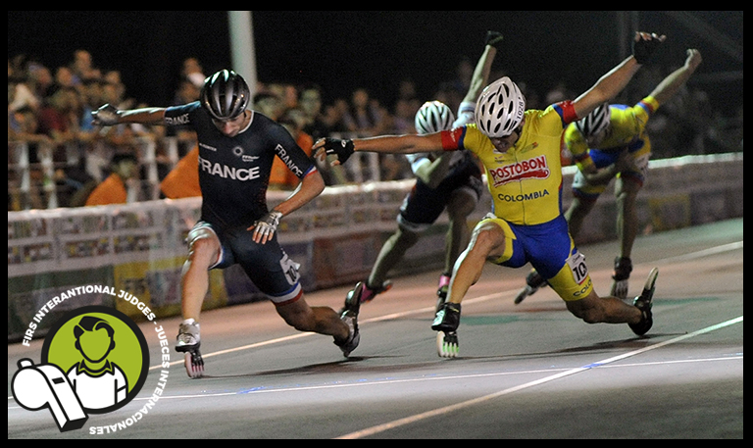

Bulletin N°1

Date 03/02/2017

Dear Presidents,

According to the Speed Technical Committee Regulations, all National Federations should submit each year -by 31 January- a list of its active International judges to the Speed Technical Committee Chairman.

As we have not received this information, please complete the form contained in the following link:

<https://docs.google.com/forms/d/e/1FAIpQLScl_ZHZQztSMTGTW7Fb932EjmQvRm84T3FQKVqD8m1R0qc5XQ/viewform?entry.163280135&entry.1783890050&entry.419551271&entry.1184098223&entry.1199928816&entry.545800192&entry.485309610&entry.1634987264&entry.494746814>

Due date: **9 May 2017**.

The relevant information for each international active speed Judge will be the basis for the appointment of Jury for the 2017 FIRS World Speed Skating Championships to be held in Nanjing.

We take this opportunity to also remind you that, all the International Judges that are not up to date with the payment of their annual fees, may not be convened and will be deleted from the official list.

The payments of the International Judges annual fees must be done, without additional costs and specifying name, country and discipline, to the FIRS:

|  |  |  |  |  |  |  |  |  |  |  |
| --- | --- | --- | --- | --- | --- | --- | --- | --- | --- | --- |
| **FÉDÉRATION INTERNATIONALE ROLLER SPORTS**   |  |  | | --- | --- | | **BENEFICIARIO** | FÉDÉRATION INTERNATIONALE ROLLER SPORTS | | **BANCO** | UBS Lausanne, Place Saint-François, 16  1003 Lausanne, Switzerland | | **CUENTA N.** | 0243-186105.61M | | **IBAN** | CH580024324318610561M | | **BIC** | UBSWCHZH80A | |

Thanking you for the good work that you continue doing in our sport and looking forward to receiving your kind reply,

**Best regards**

|  |  |
| --- | --- |
| **Jorge Roldán**  **FIRS Speed Technical Committee**  **Chairman** | Description: Marotta  **Roberto Marotta**  **FIRS**  **Secretary General** |