**OFFICIAL TECHNICAL BULLETIN**

-Updating Speed Technical Rules – YOG2018

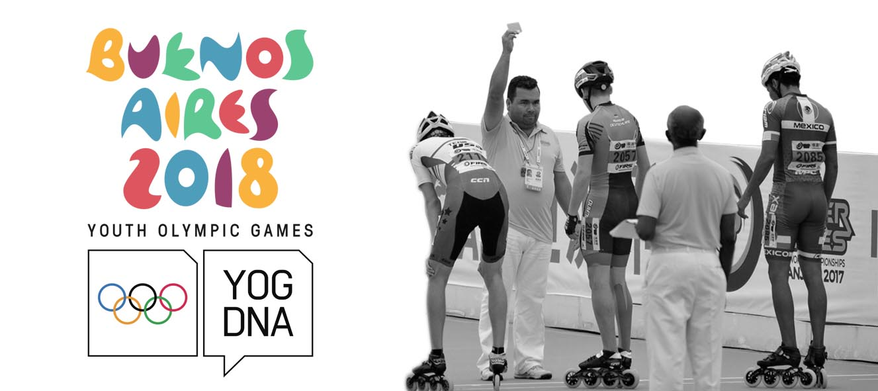

Bulletin N°3

Date 17/10/2017

Dear Presidents,

As announced on the occasion of the last Technical Meeting, held in Nanjing before the beginning of the 2017 World Championships, please find below a resume of all the changes to the Speed Technical Rules that will be in force starting from January 1st 2018.

**Deleted Races**: 300m Time Trial

Relay on Road

**Modified Races**: 500 m

One Lap

**500 m Starting Line:** In the middle of the straight

**Position in the starting box 100 m and 500 m**

**Elimination on road**:Elimination until the arrival, last elimination one lap to go.

**Claims**: claims shall be presented just to Technical Committee and shall relate only to procedures error. No claims against the evaluation of the Jury will be accepted. The video Judgments will be allowed and will be exclusively at disposal of the Jury.

**Road Course** (art. 110): The Road Circuit must be at a least 60% straight.

**WC Long Distance Heats**: The distance of the heat is over when the number of qualified skaters is obtained.

**Suspension**: When a skater is suspended after a disqualification for sport fault, he is automatically suspended for the following race even if this race is started with qualification heats.

**Podium**: for the podium will be respected the IOC Rules for the Youth Olympic Games and the IWGA Rules for the World Games.

**Inscriptions**: can only be made through the online platform.

**Junior Age**: Are considered Junior athletes all the athletes that are 15, 16, 17 or 18 years old on 31 December in the year of the Games.

Please note that you will find all these modifications in details will be available in the updated version of the Speed Technical Rules that will be published on the official World Skate website on December 2017.

**2018 Youth Olympic Games**

We also take this opportunity to remind you the qualification rules that will be applied to select the junior athletes that will attend the 2018 Youth Olympic Games in Buenos Aires.

As shared during the latest meeting in Nanjing, the speed competition for YOG 2018 will see 12 male and 12 female athletes involved.

However, the actual spots for the NFs are only 10 considering that the host city is entitled to have one athlete and one spot is reserved for the Universality Place (UPs').

The UP is a procedure the IOC has in place to support a fair inclusion of the athletes in the new Olympic sports. The process starts from the IOC that engages all the eligible NOC's in order to create a list of potential athletes that can gain the UP's spot.

So, the Youth Olympic Games will be attended by 12 junior male athletes and 12 junior female athletes (01/01/2000_31/12/2003) divided as follows:

-1 male and 1 female athletes proceeding from the hosting country;

-1 male and 1 female athletes achieved by the universality places (Ups’).

-10 male and 10 female athletes selected according to the results of the 2018 World Speed Skating Championships.

Only 1 male and 1 female skater per country can qualify.

Should you have any doubt or question do not hesitate to contact us,

**Best regards**

|  |  |
| --- | --- |
| **Jorge Roldán**  **FIRS Speed Technical Committee**  **Chairman** | Description: Marotta  **Roberto Marotta**  **FIRS**  **Secretary General** |