Rome September 09, 2010

2010 WORLD MASTERS MARATHON CHAMPIONSHIPS
Over 30-40-50-60
PAVULLO NEL FRIGNANO ( ITALY)- OCTOBER 16 and 17

Dear Sirs,
we have pleasure in communicating you that the 2010 World Masters Marathon Championships are scheduled in Pavullo nel Frignano ( Italy) near Bologna on October 16 and 17.
The event is scheduled downtown in a circuit of km 4,3 with meeting point at the Expo Village, situated in Piazza Toscani.
Organisers: AD Pattinatori Bononia in collaboration with Sportitalia srl
Website: www.sportitaliasrl.com
Email: luca.bagnolini@sportitaliasrl.com
Mobile phone: + 39 348 4409570
Fax: + 39 051 6068853

Entry Fees: 50 EUR until October 16, 2010 at 24h00; 70 EUR on October 17, 2010.
Entries to be made by sending Email or fax to Mr. Bagnolini with copy of the payment.
Bank data: Sportitalia srl, Via 2 Giugno 27/A, 400026 Imola
Bank: Popolare di Lodi
IBAN IT57G0516421010000000232545
Swift: BPALITM1820

PROGRAM
October 16
20h30 Opening Ceremony
October 17
09h00-12h00 Check of entries
14h00-16h00 World Masters Marathon Championships
18h00 Prize Awarding Ceremony

HOTELS:
For hotel bookings please get in touch directly with Consorzio Valli del Cimone, Mrs Daniela
Phone: + 39 0536 325586
Fax: + 39 0536 32 8031
Mobile: + 39 335 7427041

See all of you at the 2010 edition!

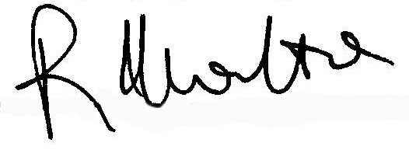

Dr. Roberto Marotta
Presidente C.I.C.

