ARTISTIC ROLLER SKATING

INTERNATIONAL SEMINAR

CITY - COUNTRY

ROME -ITALY

From 17th of January

Through 21st of January

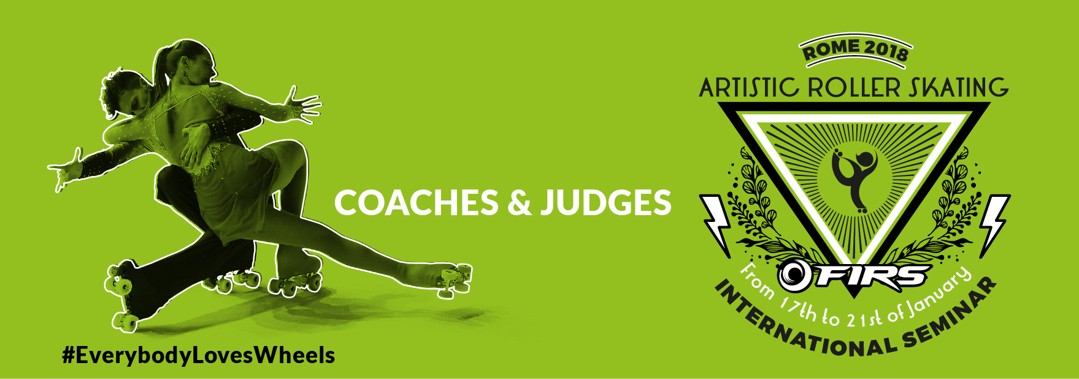

Bulletin N°03

Date

**FIRS INTERNATIONAL WORKSHOP**

**ARTISTIC - ROLLART**

**ENTRY PROCEDURE**

Entry procedure is open to trainers and judges of all the National Federations with the following rules:

**Trainers:**

Each National Federation can present a list of trainers to join the seminar in the different disciplines.

**Judges:**

It’s mandatory for the Federations that want its own nation to be represented by a judge in the following two years in FIRS competitions, the presence of at least one judge in the seminar.

Every Federation can present a list of Technical Specialists candidates for each discipline. For the candidates in Freeskating and Pairs Specialists, there will be an international test during the seminar.

**LANGUAGE**

The official language of the seminar is English with some of the lessons in Italian. It will be available the service of simultaneous translation English –Spanish - Italian.

**FIRS TRAINERS**

Every National Federation has to identify which are the trainers, for each discipline (maximum three for each discipline), to propose as FIRS coaches.

The seminar will result as an update for the FIRS trainers. To keep the FIRS Coach level, trainers must participate at one FIRS Seminar each two years (TBD).

**FIRS Coaches GOALS:**

* They will be the only ones can be at the skaters area during FIRS competition.
* They will be taken into consideration as instructor for local seminars or national seminars in the territory around their nation.
* They will be the ones participating to technical meeting with the FIRS ATC.
* Their point of reference will be FIRS ATC.
* They will be the ones to propose changes or technical modifications to the disciplines they represent.

# ENTRY FEES

The following entry fees include:

* Seminar.
* 4 Nights and Full accommodation: English Breakfast, Buffet Lunch, three courses dinner.
* Simultaneous Translation (English, Spanish, Italian).
* Gadgets.

Entry Fees for trainers

- Triple Room 480€ per person

- Twin Room 580€ per person

- Single Room 680€ per person

For JUST the seminar:

380€ per person

**THE DEADLINE FOR ENTRY IS 30/11/2017**

# The following is a not detailed schedule. FIRS is working on how to manage it in the best way.

# SEMINAR SCHEDULE - PROVISIONAL

**Wednesday 17/01/2018**

**14:00 Check IN Hotel**

**Thursday 18/01/2018**

**09:00-19:00 Seminar Auditorium/Seminar Room**

**Friday 19/01/2018**

**09:00-19:00 Seminar Auditorium/Seminar Room**

**Saturday 20/01/2018**

**09:00-19:00 Seminar Auditorium/Seminar Room**

**Sunday 21/01/2018**

**08:30-13:00 Test for Specialists (Freeskating, Pairs) - Seminar Room**

**08:30-13:00 Verification for FIRS Trainers - Auditorium**