NEW INFORMATION
FIRS Athletes’ Commission
Athletes’Election 2017-2020

Senior skaters competing in the 2016 World Artistic Championships will have the opportunity to nominate and vote for one male and one female skater also competing in the 2016 Championships. The male or female with the highest number of votes will represent them with the second highest male or female being the alternative, but both will not be Member of the FIRS Artistic Committee. If they have competed in a World Artistic Championship in the past 3 years they are also eligible, as this was agreed at the FIRS Executive Board Meeting held in Nanjing two days ago. The nominees must be 18 years and over and be able to communicate in English and Spanish
The objectives are to consider issues related to athletes representing their rights and interests.
The members’ term of office will be 4 years.

Please submit your nomination on the form below and bring to the FIRS Artistic Technical Office in Novara, by Monday October 3, 2016
Voting will take place on Tuesday October 4 between 10.00-12.00 a.m. in the FIRS Artistic Office. Voting is not compulsory but is recommended.
Scrutineers for the voting will be Margaret Brooks FIRS Artistic Chairman and two Senior skaters from different countries, where there are no nominees from their countries submitted.
For any additional information, please see the “FIRS Athletes Commission” in the FIRS Bylaws at the following link - http://www.rollersports.org/about-firs/charts
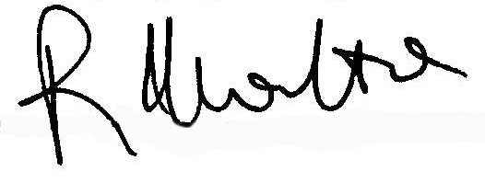
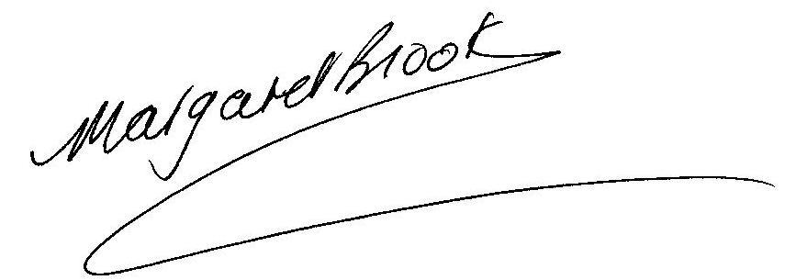
Margaret Brooks Roberto Marotta
Chairman FIRS ATC Secretary General

NOMINATION FORM
(To be submitted to FIRS Offices by Monday, October 3, 2016)
FEMALE.................................................................................................................................

(Please PRINT Full Name)

MALE....................................................................................................................................

(Please PRINT Full Name)

